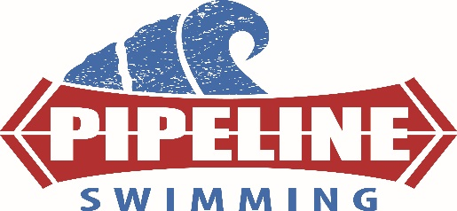

NO DRAMA POLICY!!!! ATHLETES & PARENTS
Prior to joining PIPELINE SWIM TEAM everyone has had a chance to talk with the coaching team and at least 1 of the team owners i.e. Patrick Piper regarding team policies. These policies are designed to keep our team moving forward in a positive direction. PIPELINE is building more than great swimmers -- we are building a great team starting with the environment. A positive environment bread great team as well as great teammate, leaders and even friends. Our NO DRAMA POLICY is key to our teams’ success. This policy is one part of the online registration process. Anyone who would like a hard copy can request one for their own records.
The NO DRAMA document is for you and or your parents to read, sign and understand the importance it has with our program. The rules for PIPELINE are NOT optional. Any violations to these rules will result in a series of consequences that ultimately could lead to removal from the team. Breaking of these rules even by the parents could result in the athlete’s removal from the team. Keep in mind we hope it never comes to this point.
- Always be positive! Being positive is a choice… Not everyone has the best day every day. Although you all can be positive to each other which will lift each other up.

- No Prima-donna allowed. (Definition)“a very temperamental person with an inflated view of their own talent or importance “ There is no “I” in TEAM. It is not all about you – you are part of what makes up team PIPELINE! Simply put treat everyone with respect.

- NO Phones/Electronics – during practice, during drylands and during meets (get up and cheer!)

- BBB – NO baiting, gaslighting, badgering or bullying teammate, coaches, parents or opponents. This includes negative talk or posting negatives things or pictures about all listed above in any format, including but not limited to the following:
Facebook Twitter/x SnapChat Verbal
Instagram Flickr LinkedIN Written
Tumblr YouTube Text
Vine Vimeo Email

- Be polite – Use your manners “Please and Thank You,” ect this includes clean language.

- Be Respectful – Respect each other, our training facilities and any guests including coaches and officials. This includes the following
  - Parents do not be a distraction or create a seen during practice or meets including
    - No parents on deck during practice and meets unless they have an open deck meet which has been published
    - No yelling at other athletes, coaches or officials
    - No bad language
    - No gossiping or spreading rumors

  - Clean up the deck after each practice including your own training equipment and any other items --
    - Water bottles & trash
    - Caps & Goggles
    - Equipment and bags
    - Shoes & Clothes
    - Put block covers / cones back on blocks
    - Push all chairs back in
    - Remain in and change in Swim team area ONLY (no club locker rooms)

Don’t whine online!

SOCIAL MEDIA is here to stay. It can be used for GOOD or EVIL. Use it only for GOOD and to boost up our team or teammate!

Communication for top level group members - Each member of our competitive groups may be invited to join our Nat’l BAND app for communication and open forum for all to read. This communication will be for updates or changes to practice, warmups times or weather info. This is NOT a 2 way communication path. Any questions about what is posted needs to be text form to the coach who made the post, and this should be a Triangle communication.

Triangle communications is a required. What does this mean? No 1 on 1 direct text or emailing between coach and athlete! A Parent, athlete & coach i.e. Triangle for all communication for anyone’s safety and anyone under the age of 18 years old.

I have read and understand the above:

Parent signature: _________________________________________

Date: _________________ Cell # : ________________

“Positive thinking will let you do everything better than negative thinking will.” - Zig Ziglar

